Zendaya Fashion Store – Technical Report

Table of Contents

Introduction

The aim of Zendaya fashion store is to provide an easy to use and efficient outlet for customers to buy the fashion offerings of our client. Our system has three different levels of stakeholders: Admins, Store Managers and customers. The admin will be able to manage the system as a whole and also be in charge of adding Store Managers. The Store Managers will be able to add and manage products and keep the product details up to date. Each Product will have be able to have their details, a discount and a maximum of four images, furthermore the products will have user feedback and they can be sorted into categories. The customers will be able to browse the products without logging in and need only create an account if they wish to purchase something.

Features
- Diagrams

- The Use Case diagram:
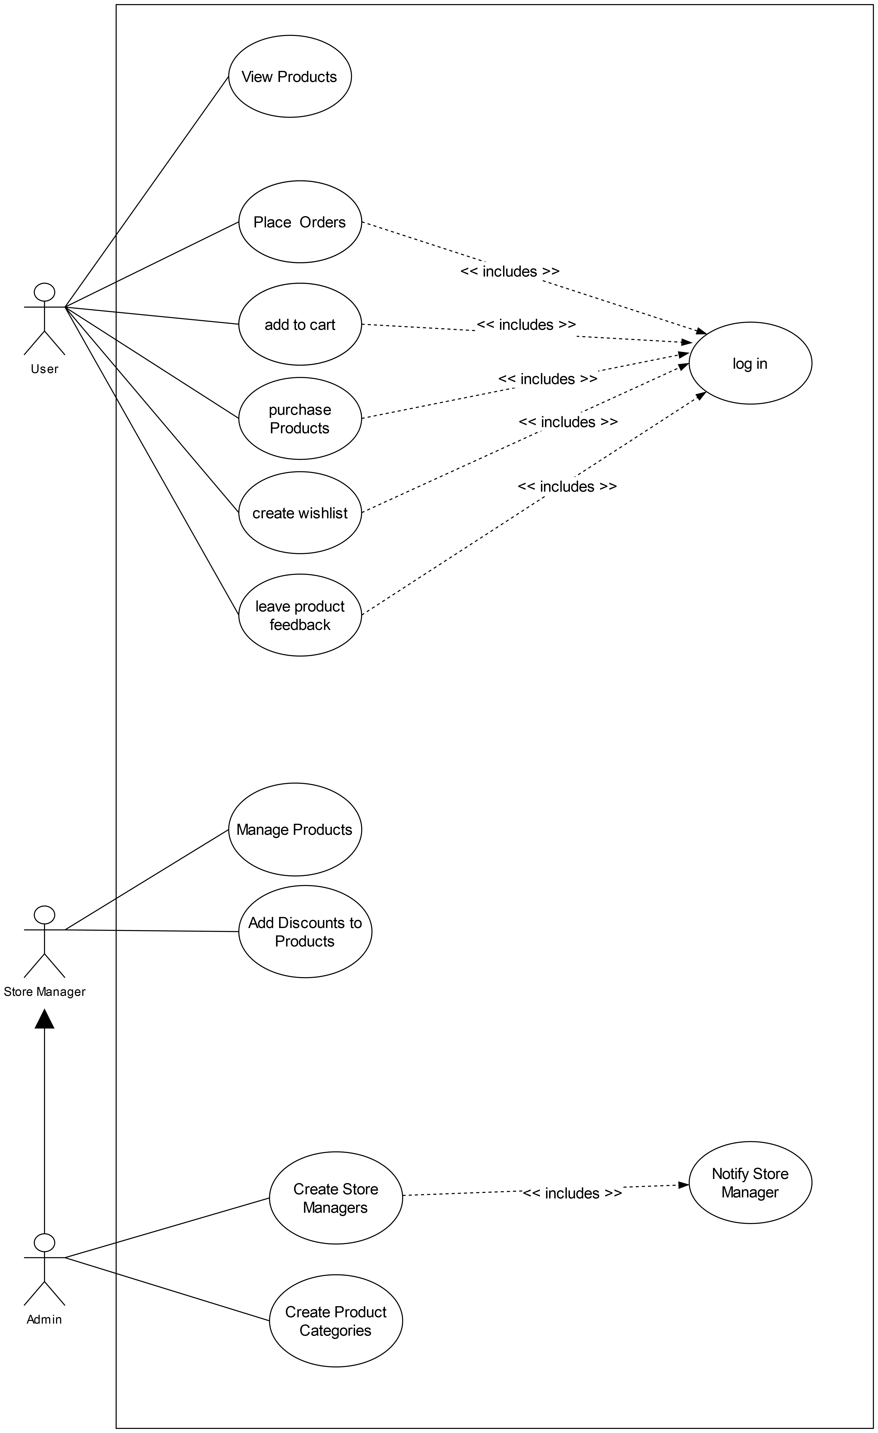

- Front End

- Back End

- The Back-end was developed using spring and the database was MongoDB.
- User details were stored together and users were separated by using a “role” attribute. This helps us identify if the person logging in is a normal user, admin or store manager.
- For security all passwords are hash-coded before storing/using, this is to avoid storing plain-text passwords.
- Products have a name, description, price, discount percentage, user feedback details and up to 4 images, one of which is used as the thumbnail.
- Product images are also stored in MongoDB, When the front end sends an image it is stored as Binary under that product. If the front end request the image then the image is reconstructed in the server before being sent to the front-end.
- Products could be sorted into categories which would have the category name and a list of products in the category. A particular product could fall into multiple categories.
- A history of each users purchase is stored and made visible to the user. This offers the ability to view past purchases and also see the delivery status of the product.
- When paying for products the user has the option of either paying using a card or pay by cash-on-delivery.
- Security of the system is provided by requiring jwt tokens with all requests for authentication.

- Testing

- Tests for Spring were written using the TestNG Framework.
  - First the test will start up the spring boot application
  - Next it will create a temporary Test user by calling “/createAdmin” and use it to obtain the jwt token needed to make requests.
  - Then it will test product functionality by calling “/addProduct”, "/addReview", "/updateProduct" respectively with appropriate JSON body.
  - If above test passes, it will test Product category functionality by calling "/createCategory", "/addToCategory", "/removeFromCategory", "/getAllCategories", "/deleteCategory" respectively with appropriate JSON body.
  - If above test passes, it will test Wish List functionality by calling “/addToWishList”, “/moveToShoppingCart”, “/removeFromWishList” respectively with appropriate JSON body.
  - If above test passes it will test Shopping Cart functionality by calling "/addToShoppingCart", "/getTotalPriceAndNumberOfItems", "/getProductsAndDetails", "/removeFromShoppingCart", "/purchaseItemsInCart" respectively with appropriate JSON body.
  - If above test passes it will test Payment functionality by calling "/getPaymentHistory", "/getPaymentDetails", "/setOrderStatus", "/getOrderStatus" respectively with appropriate JSON body.
  - Finally it runs a clean up function where it will delete the product it created specifically for the test.

- Deployment

- The Backend was deployed to a Virtual Machine on Google cloud, running Ubuntu.
- The Database was deployed on mongoDB Atlas.

Conclusion

